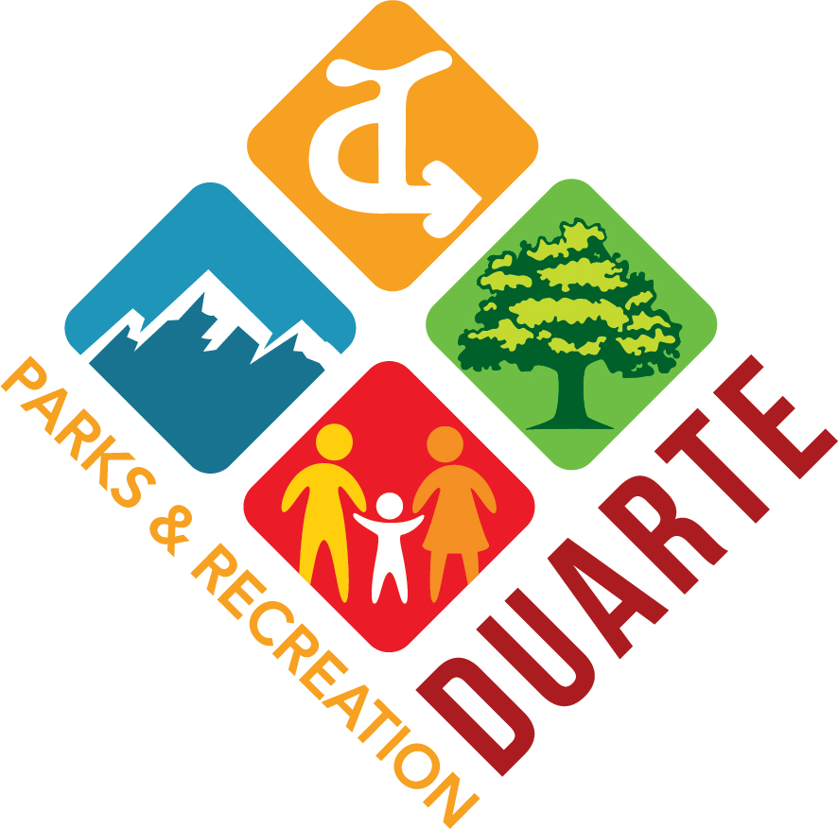
CITY OF DUARTE
PARKS AND RECREATION COMMISSION
AGENDA

May 13, 2024
7 PM

COMMISSION CHAIR: Alexander Streff
COMMISSION VICE-CHAIR: Jennifer Luna-Nguyen
COMMISSION MEMBERS: Barbie Bylsma-Houghton, Ceci Carroll, Anne Wilkins

- CALL TO ORDER

- ROLL CALL

- PLEDGE OF ALLEGIANCE

- ITEMS FROM PUBLIC (3-minute time limit per person)

- APPROVAL OF MINUTES

    - Minutes from Parks & Recreation Commission Meeting on
March 11, 2024

- ITEMS OF BUSINESS

- Royal Oaks Park Gazebo Replacement | Color Selection
- Discussion Continuation: Location of Duarte Community Garden
- Update: Donald & Bernice Watson Recreation Trail

- ITEMS FROM STAFF

- ITEMS FROM COMMISSIONERS

  - Commissioner Reports

- ADJOURNMENT

In compliance with the Americans with Disabilities Act, if you need assistance to participate in this meeting, please contact the Parks and Recreation Department at (626) 357-7931. Notification no later than 1:00 p.m., on the day preceding the meeting will enable the City to make reasonable arrangements to assist your accessibility to this meeting.

Note: Any documents distributed by City Staff to a majority of the Commission less than 72 hours prior to the Commission meeting will be made available for public inspection at Duarte City Hall, 1600 Huntington Drive, Duarte, CA 91010, during normal business hours, except such documents that relate to closed session items or which are otherwise exempt from disclosure under applicable law.

